# Lab 1 – Provision HDInsight Cluster

### Provision HDInsight Linux Hadoop clusters with Azure Management Portal

To provision HDInsight Windows Hadoop clusters with Azure Management Portal, perform these steps:

1. Go to the Azure Portal portal.azure.com. Login using your azure account credentials.
2. Select **NEW -> Data Analytics -> HDInsight**

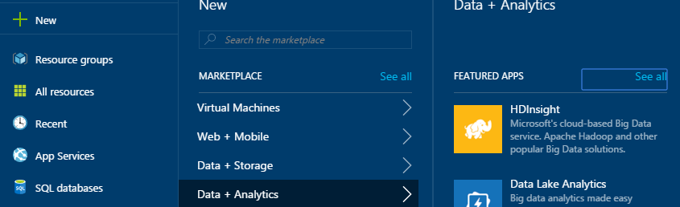

1. Enter or select the following values.
   1. **Cluster Name:** Enter the cluster name. A green tick will appear if the cluster name is available.
   2. **Cluster Type:** Select Hadoop as the cluster type.
   3. **Cluster Operating System:** Select Linux as the cluster operating system
   4. **Version:** Select 3.6 as the cluster version.
   5. **Cluster Tier:** Select the **Standard** cluster tier

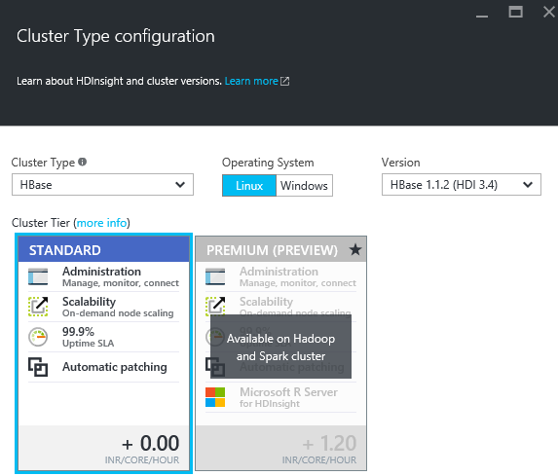

* 1. **Subscription:** Select the Azure subscription to create the cluster.
  2. **Resource Group:** Select an existing resource group or create a new resource group.
  3. **Credentials:** Configure the username and password for HDInsight cluster and the SSH connection. SSH connection is used to connect to HDInsight cluster through a SSH client such as Putty.

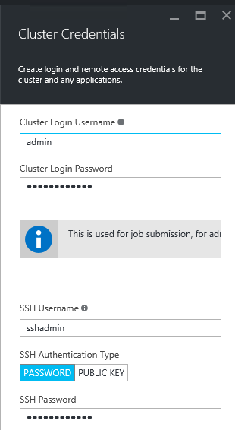

* 1. **Data Source:** Create a new storage account and a default container.

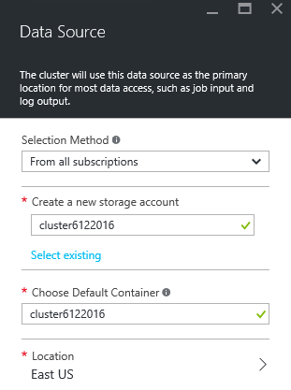

* 1. **Node Pricing Tiers:** Set the number of head node and worker nodes as shown below.

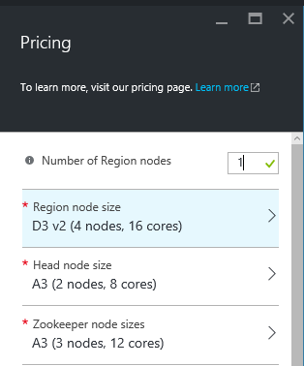

**Note:** You can select lowest pricing tier A3 nodes or reduce the number of worker nodes decrease the cluster cost.

* 1. Leave other configuration options as default and click **Create** to provision HDInsight Hadoop cluster. It will take 15-20 minutes for cluster provisioning.

**The HDInsight Linux Hadoop cluster is now ready to work with.**

## Copy lab data to the storage account

In this section, you’ll copy the files required for the lab to your storage account.

To copy the files, follow the below steps.

1. Launch Azure Storage from your cluster dashboard

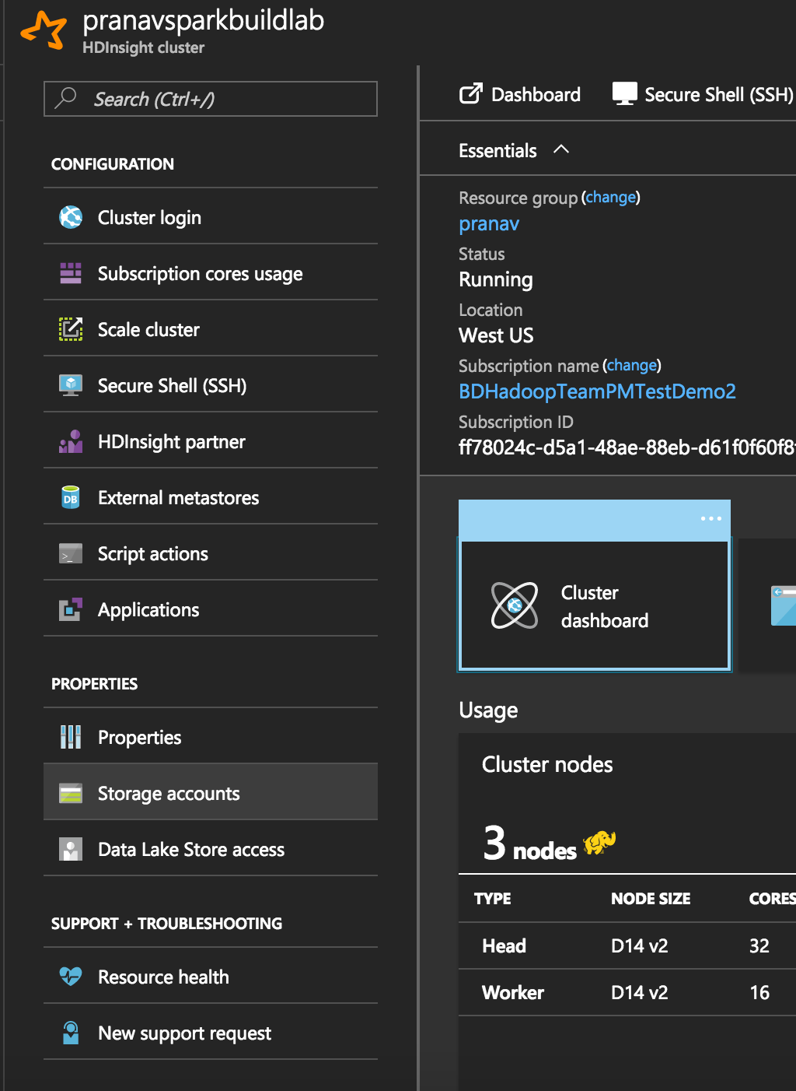

1. Select the **Blob container** for your cluster
2. Create a directory under **/** called **HDILabs**
3. Navigate to **HDILabs** and create a directory called **Lab1**
4. Upload weblogs.csv to **Lab1**. Weblogs.csv can be found in **Student-Resources\Labs\ \data** folder.

